Step1: Go to file section, and click on New Virtual Machine.

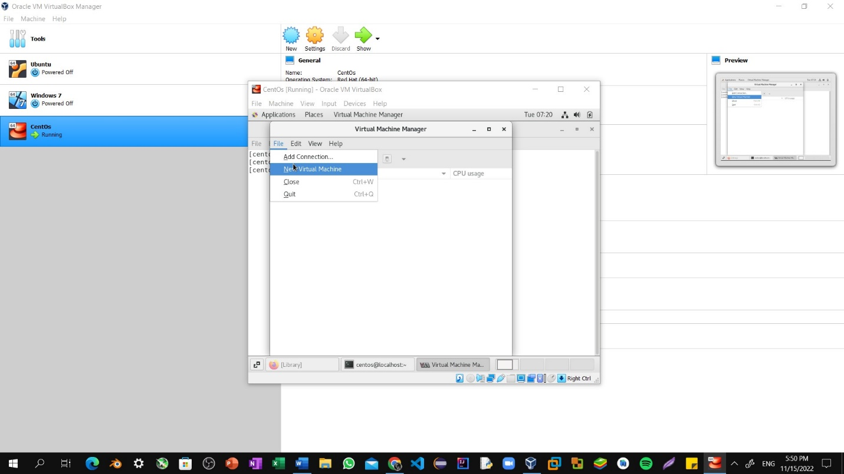

Step2: Remain Default Setting as it is and click on forward.

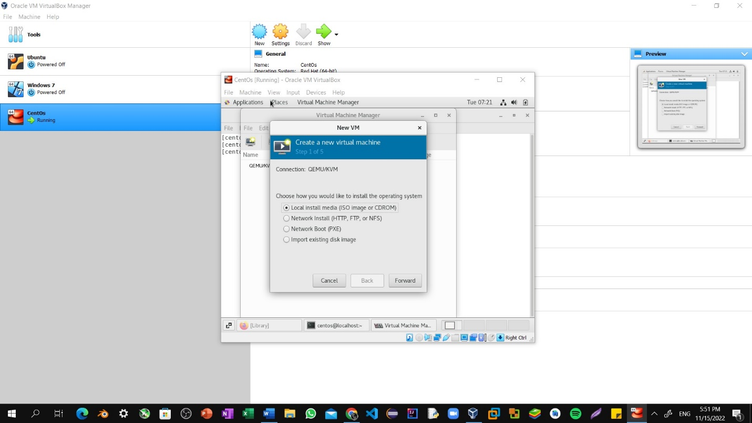

Step3: Now Select Memory and CPU depending upon the Usability.

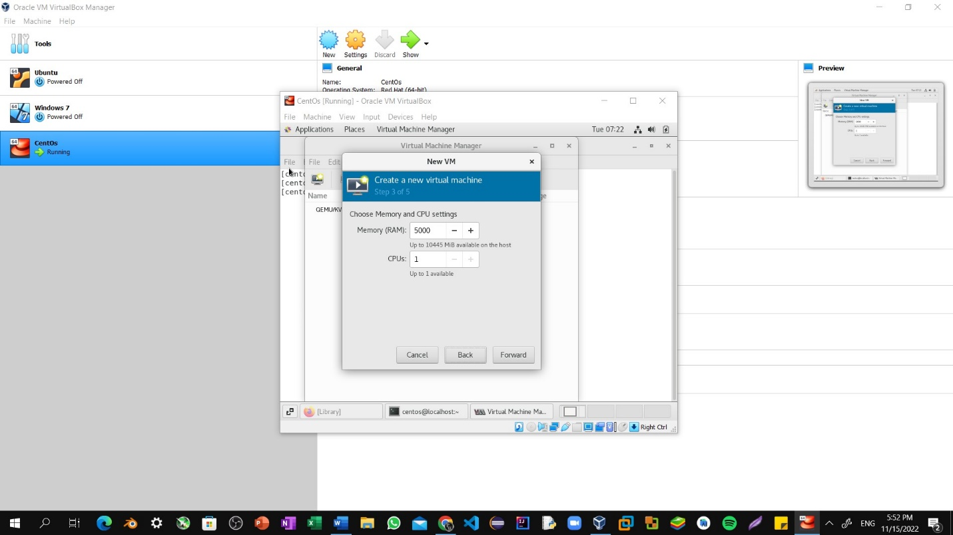

Step4: Now, Keep The default Settings as it is and then proceed further.

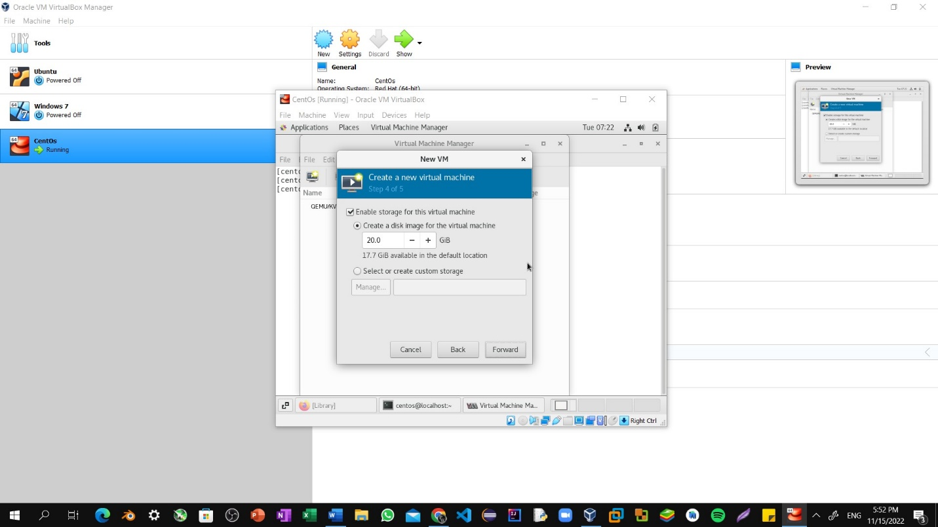

Step5: Now, Keep The default name as generic settings as it is and then Finish button.

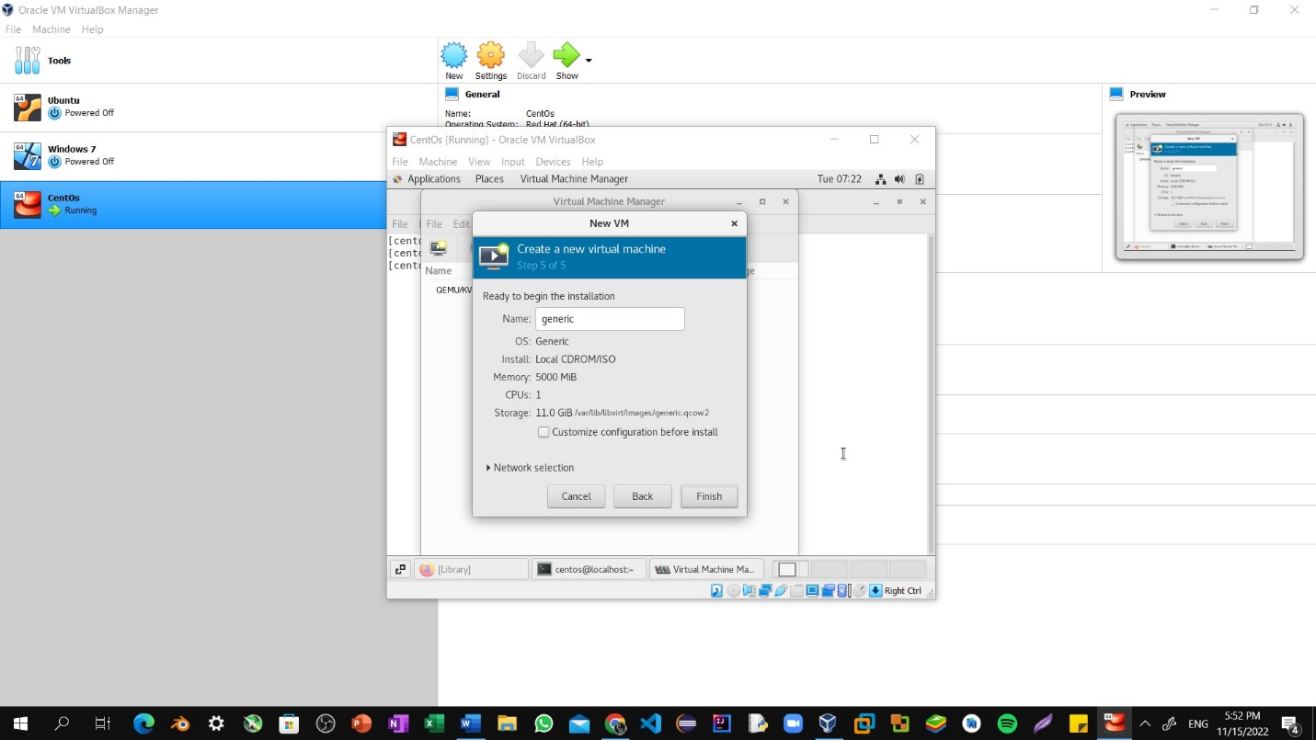

Step6: Now start the installation of virtual machine by clicking install ubuntu.

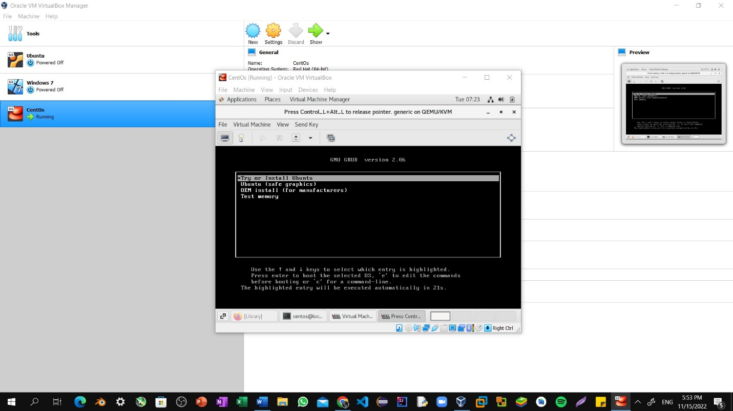

Step7: Now select English language and Click on Install Ubuntu.

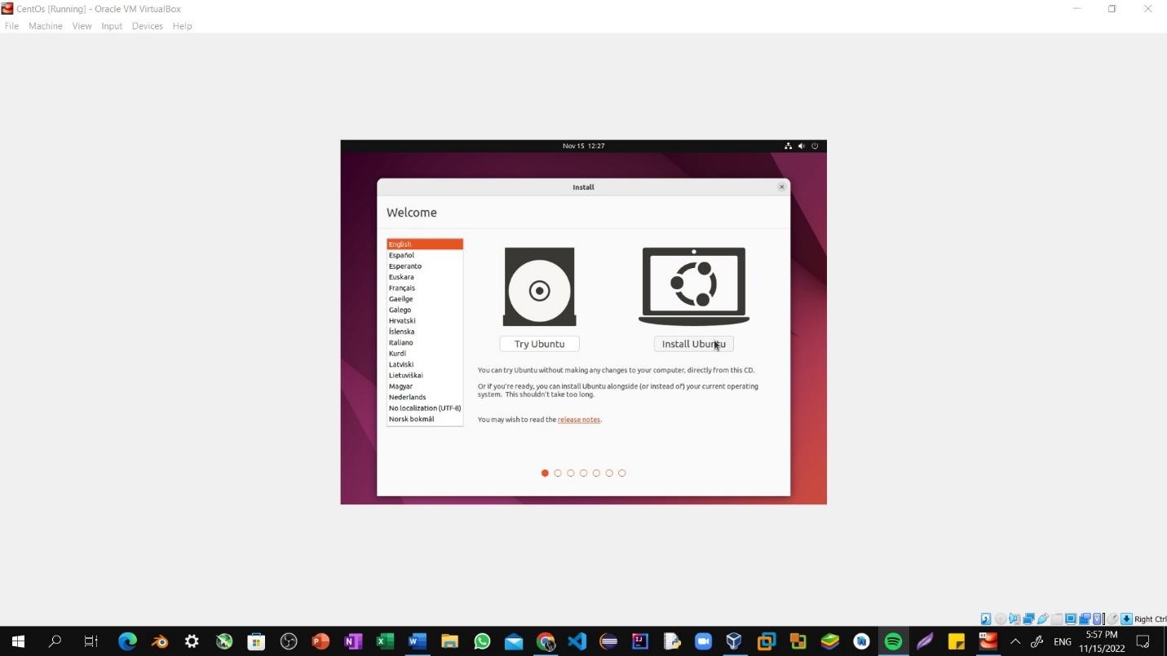

Step8: Check normal installation, download updates while installing ubuntu, install third party software for graphics and then click on next. 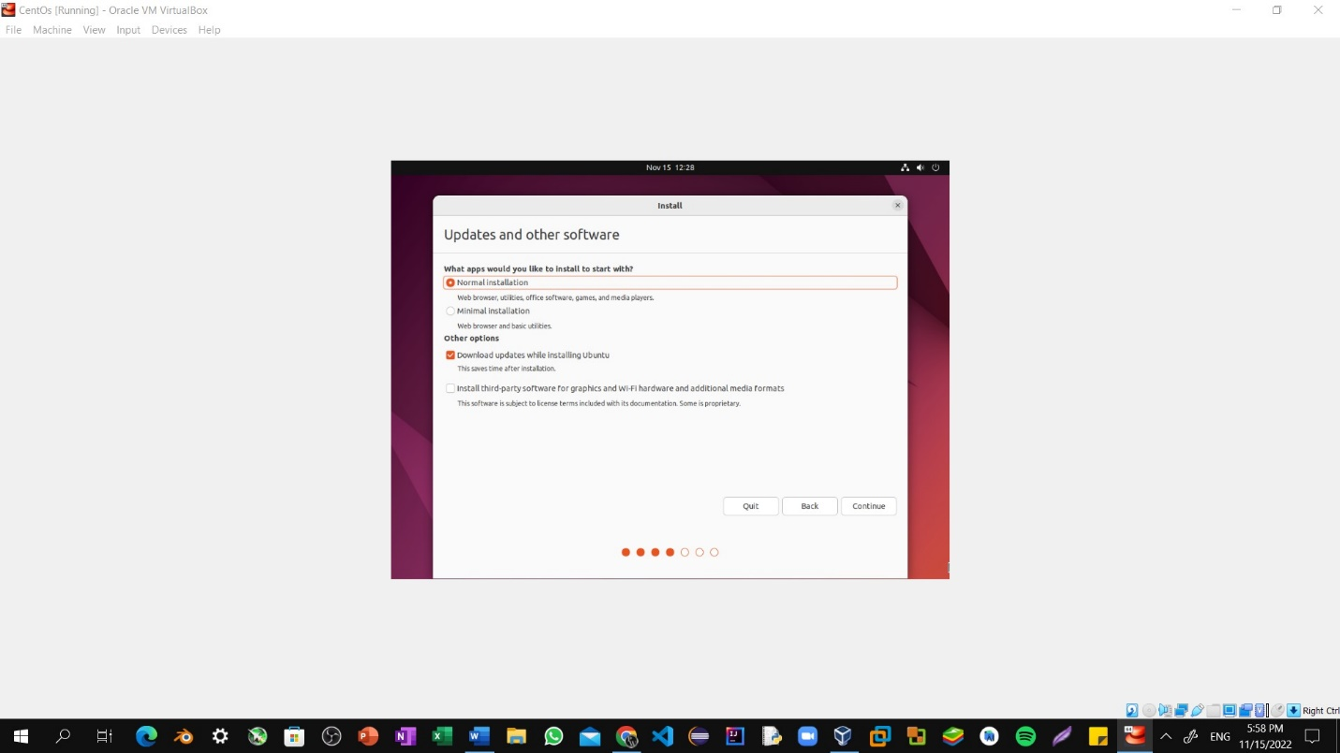

Step9: Check Erase Disk and install ubuntu, this Erase Disk option doesn’t affect current operating system it only make changes to Virtual Disk. Now Check Install Now option.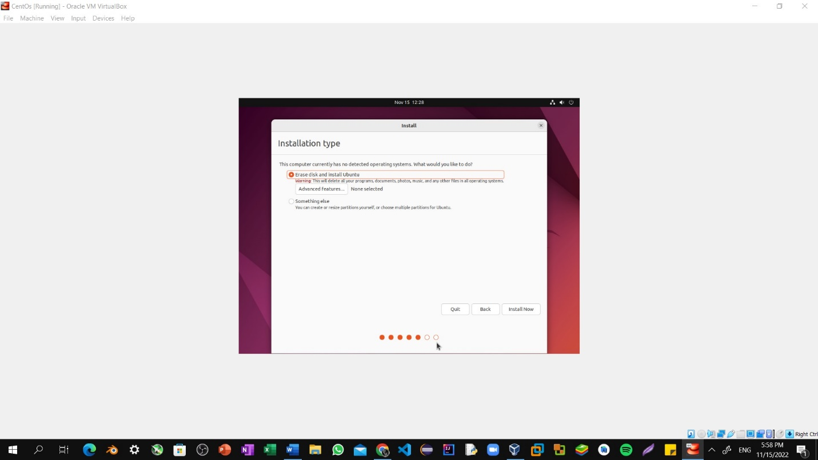

Step10: Now setup virtual machine username and password. 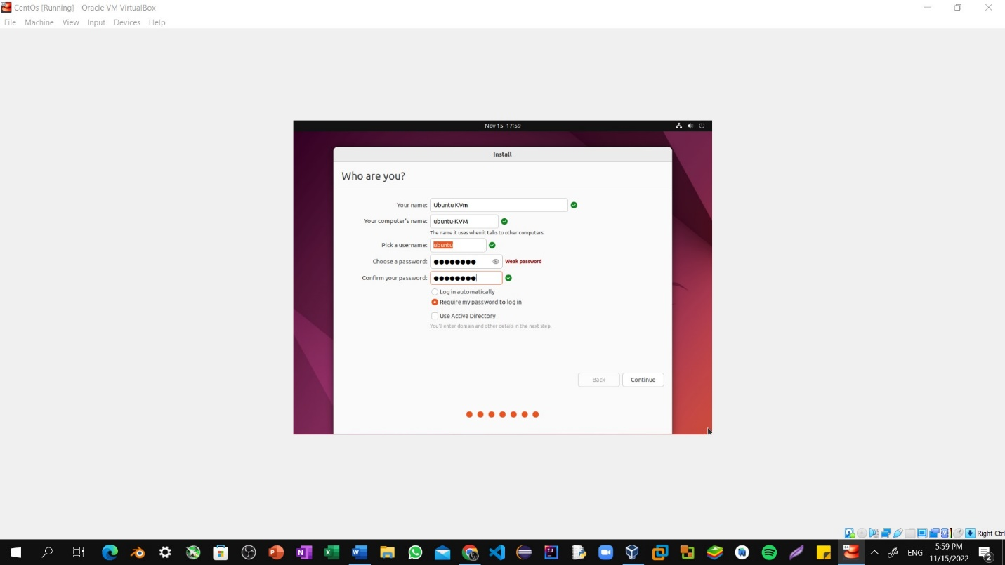

Step11: Now wait for few minutes until installation get completed.

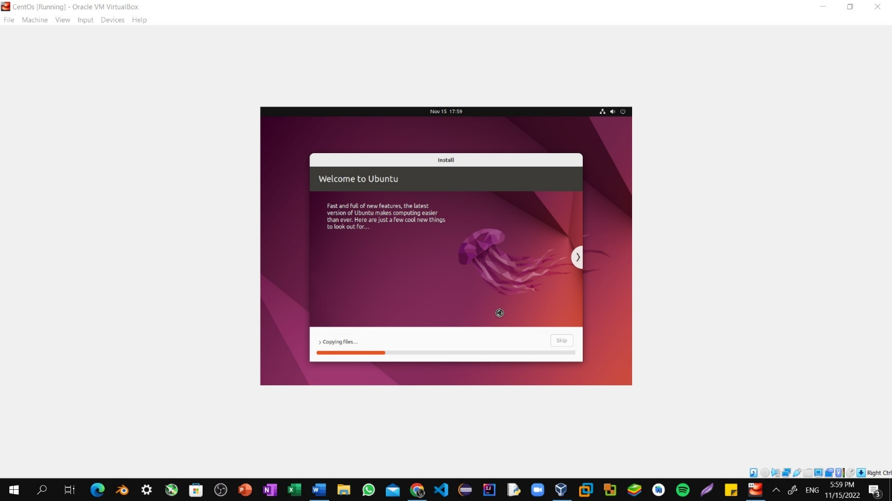

Step12: Once the installation is completed. We need to restart Virtual machine in order to use.

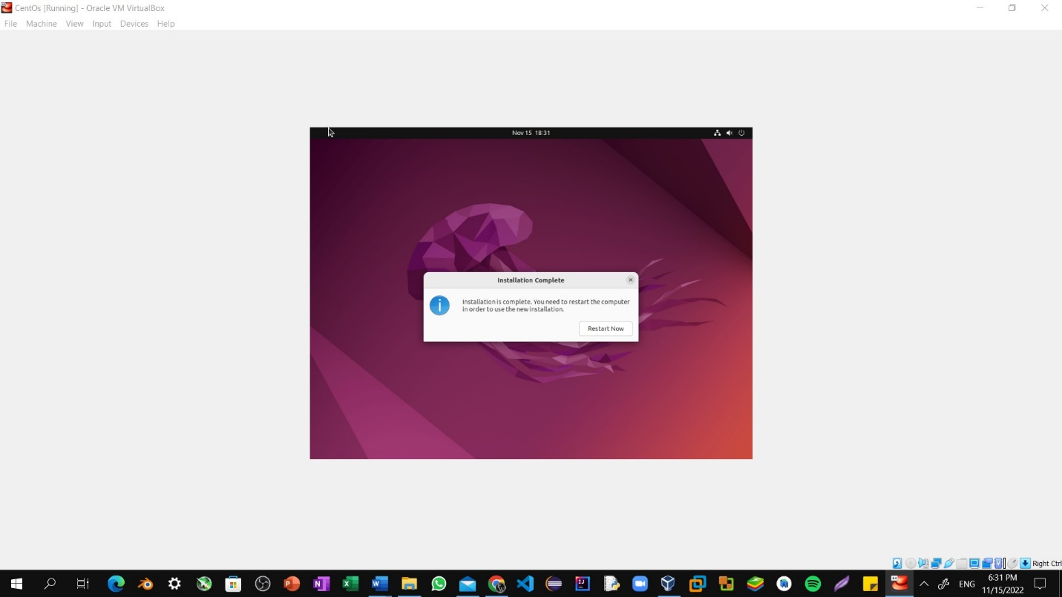

Step13: Now, Enter your password and login to your workspace.

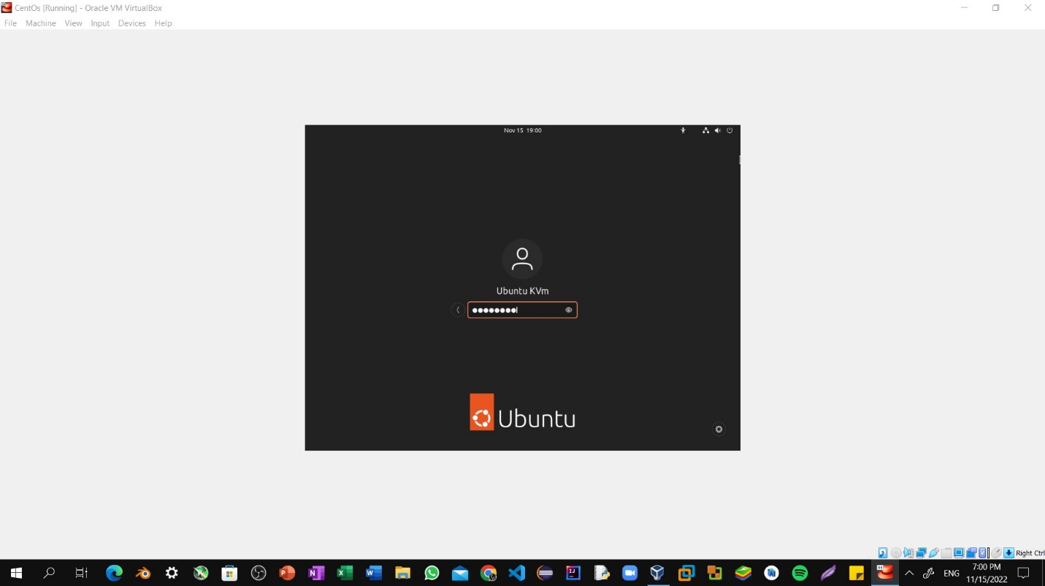

Step14: Ubuntu Workspace.

